Macon Davayé Oenological Forum Union of Burgundy Oenologists 05/02/2019
https://www.macon-infos.com/index.php?option=com_content&view=article&id=20190:davaye-18th-forum-oenological-of-davay&catid=81&Itemid=294&lang=en

THERMAL OPTIMIZATION OF WINERIES AND EXAMPLES OF REALIZATIONS

Joël ROCHARD, Sustainable Development Expert,
French Institute of Vine and Wine.
rochard.joel@gmail.com
http://joel-rochard.com/en/

1_INTRODUCTION

Man has seen his energy consumption increase with exponential growth since the primitive period. From a few thousand calories (food requirement), individual daily consumption currently reaches more than 250,000 kilocalories in modern technological civilization (domestic, industrial and agricultural consumption, transport).

Both viticulture and agriculture have developed mechanisation since the middle of the 20th century. But beyond direct energy consumption (tractors, harvesting machines), intermediate wine products (fertilizers, plant protection products) generate an increase in energy consumption.

Concerning oenology, winegrowers often knew by empiricism the importance of thermal aspects during the elaboration of a wine. All means that allowed to benefit from the coolness or natural heat were used (underground cellars, opening of the cellars during the winter, window wells oriented according to exposure or prevailing winds). In addition, the winter cold was used to ensure the tartaric stabilization of the wines.

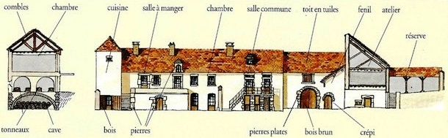

Traditional Burgundy winegrower's house. Source: encyclopedia of French wine tourism, Editions Hachette, 1994.

However, vinification remained highly dependent on the unchanging cycle of the seasons and the weather conditions of the year. Thus, in recent years, quality requirements, the need to ensure perfect biological and physico-chemical stability of wines, the reduction of winemaking cycles, the establishment of cellars on the surface have tended to generalize thermal applications throughout the winemaking process.

The main thermal effects used in oenology are as follows:

Cooling :
+ Optimization of sedimentation
+ Reduction of enzymatic activity (oxidation, ageing)
+ Limitation of volatilization (alcoholic fermentation, ageing in barrels)
+ Regulation of fermentation metabolism (white wines)
+ Limitation of the multiplication of microorganisms (risk of disease, blocking fermentation)
+ Precipitation of tartaric acid salts
+ Ice formation (cryoextraction)

Heating:
+ Increase in bacterial and yeast multiplication (alcoholic and malolactic fermentation)
+ Optimisation of extraction and diffusion processes (tannins, colouring materials)
+ Destruction of microorganisms (pasteurization)

 | Temperature
Technical and reception areas | 17 to 22°C
Barrel cellars | 12 to 15°C
Bottle cellar | 12 to 15°C  For wine 16 to 18°C
Storage in tanks | 12 to 15°C  (18 to 20°C for malolactic fermentation and -4 to 0°C for tartaric stabilization)

Optimal temperatures of the production sites

The choice of an optimal temperature during a winemaking stage often represents a compromise between the favourable and unfavourable actions of the thermal effects on the wine.
These treatments (tartaric stabilization, pasteurization, etc.) vary significantly according to the type of processing. In addition to choosing an optimal temperature, the use of heat exchangers reduces thermal requirements. Wine treated with cold (or heat) brings some of its frigories (or calories) to the wine to be treated. Traditionally, cellars and sometimes conservation vats were dug in the basement, which made it possible to obtain a good temperature regularity (12 to 15°C). However, this type of installation sometimes leads to excessive humidity, which justifies the use of a dehumidifier. For economic (earthmoving costs) and logistical (freight elevator) reasons, a large number of new cellars and vats are located on the surface. For most climatic zones, air conditioning is essential to maintain a storage temperature of 12 - 15°C. In some cases, heating the premises or wines to 18-20°C should be considered during malolactic fermentation.

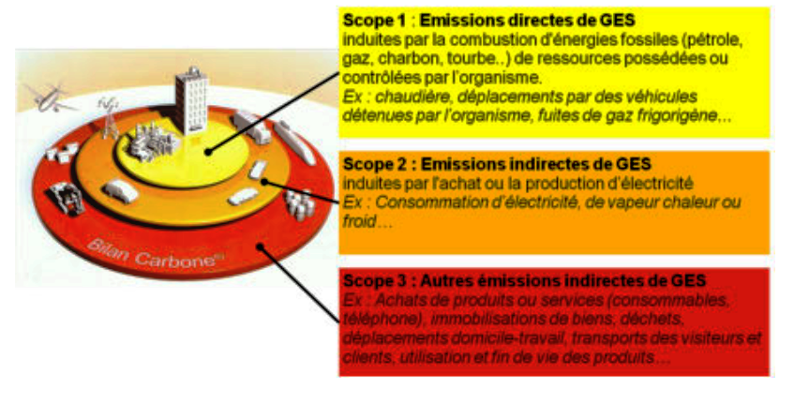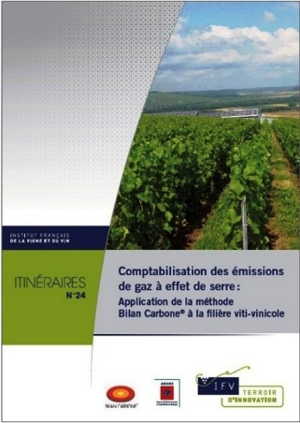

Carbon footprint principle (lamy-environnement.com scheme) and brochures greenhouse gas accounting itinerary (www.vignevin.com)

The ECOWINERY project was carried out within the framework of the Leonardo Da Vinci programme (Lifelong Learning) funded by the European Commission. It included a partnership of 5 complementary organizations: The French Institute of Vine and Wine in France (coordinator) for its technical, normative and regulatory expertise, the University of Applied Sciences of Aschaffenburg (Germany), a specialist in the management and optimisation of energy and renewable energies, the Autonomous University of Barcelona (Spain) in collaboration with the Catalan Institute of Vine and Wine for their technical knowledge of the sector and Changins the University of Viticulture and Oenology in Switzerland, in charge of transposing the content of the awareness modules associated with an educational and methodological approach.
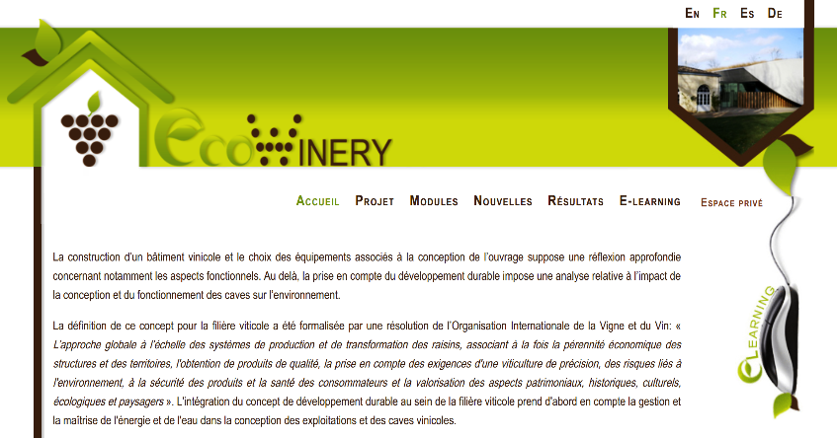
EcoWinery project website www.ecowinery.eu
Its objective was to provide E-learning training materials for the eco-design of wine buildings to winegrowers, oenologists, domain managers, consulting technicians, architects, teachers and students in viticulture and oenology (initial and continuing training). The training is structured around 5 modules:
- Module 1: Regulatory Context.
- Module 2: Architectural and eco-construction approach.
- Module 3: The energy resource associated with the building (geothermal, solar, heat pump, roof or green wall) and thermal recovery.
- Module 4: Optimization of water use in a wine cellar, saving and ecological management of effluents.
- Module 5: Monitoring and evaluation of an eco-design project for a wine cellar and its environmental impact.

2 _ ARCHITECTURE AND BUILDING DESIGN

2-1_ Thermal diagnosis

The integration of the concept of sustainable development within the wine sector primarily involves adapting wine-growing and oenological routes to environmental constraints, but also, with a long-term vision, taking into account energy aspects and water management in the design of farms and cellars.
The energy diagnosis carried out both at the global scale of the operation and at the level of a production workshop, equipment or building, constitutes the keystone of the energy performance plan. It makes it possible to take stock of energy consumption and, above all, to identify the margins for progress and the actions that farmers can take to improve the energy performance of their farms, their production, their equipment or their buildings. These actions can focus on the adoption of more energy-efficient practices (reduction of nitrogen inputs, modification of technical routes, etc.), the use of equipment that improves energy performance and in some cases they can lead to the production of renewable energy.

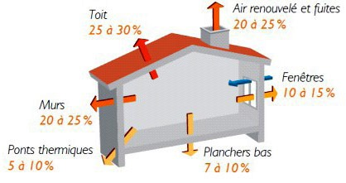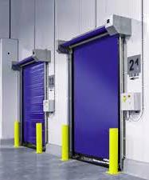

Main thermal losses of a building (Source: ADEME Guide Insulate your home) and
example of limiting temperature variations by installing doors / curtains with quick opening/closing.

2-2 _Inertia of building materials

Beyond the annual temperatures, it is also important to take into account the thermal variation between day and night and from one day to the next during the week. A good thermal inertia of the building (without internal insulation) can be obtained by using dense materials (stone, concrete). The high thickness (40 to 50 cm) single-walled cellular brick is also interesting. However, it requires a specially trained workforce. Indeed, the bricks interlock and are joined only by a thin mortar.

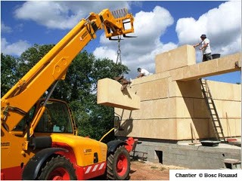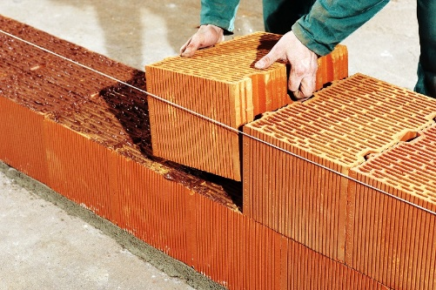

A good thermal inertia of a building can be achieved with a solid stone.
Example of the Gard stone, (photo parchitecture-en-pierre.blogspot.com) and the "monomur" honeycombs of great width, Photo www.travaux.com

2-3 _Subsoil thermal energy and geothermal energy

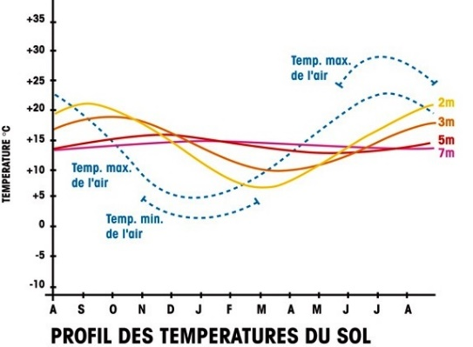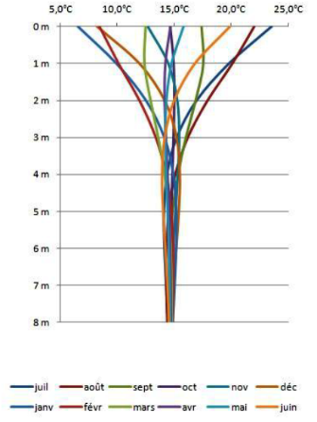

Diagrams of temperature variation during the year as a function of depth, Source: colibri-construction.fr.

Geothermal energy, from the Greek geo (the earth) and thermos (heat) refers both to the science that studies the internal thermal phenomena of the earth and to the technology that aims to exploit it. The geothermal flux of the earth is generally far too low to be used directly with a "high temperature" process except in areas with thermal springs or surface magmatic chambers. Nevertheless, below 4.50 to 10 m, the ground temperature is constant throughout the year. This is close to the annual surface average (11 to 16°C in European wine-growing regions). The traditional use of the thermal inertia of the basement consists in burying all or part of the cellars. Nevertheless, this solution, which makes it possible to limit the footprint, is not always possible (cost of excavation, presence of a groundwater table, wet ground, etc.) It is also possible to consider using this thermal inertia of the basement by a vertical underground probe system (low enthalpy geothermal energy) or a horizontal pipe system with air transfer (Canadian well). In the case of vertical capture, heat recovery takes place from one or more boreholes with a depth of 80 to 120 metres. The system consists of a single polyethylene U-shaped tube containing a fluid under pressure and in a closed circuit. The advantages of this system (small occupancy area and constant temperature at a depth of 100 or 150 metres) make it possible to consider a location in most sectors with nevertheless an economic constraint related to the drilling.
The Canadian well uses the thermal inertia of the ground with horizontal pipes at a depth of about 1 to 2 metres to pre-treat the ventilation air in buildings. From a practical point of view, the soil temperature at shallow depth is about 15°C in summer and 5°C in winter. This device can be equipped with anti-pollutant filters and must be equipped with a drainage siphon for condensation water inside the pipes.

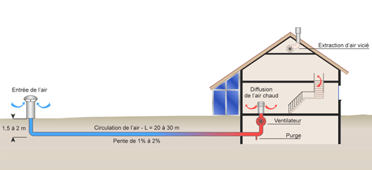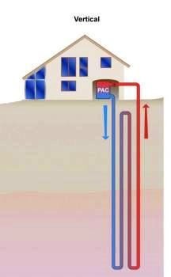

Use of thermal inertia by air transfer from horizontal buried pipes (Canadian well) or by fluid transfer in vertical probes (low enthalpy geothermal).

3 _VENTILATION AND INSULATION

3-1_Ventilation

A renewal of the cellar air is necessary in order to limit the humidity level and to clean up (smell, micro-organisms) the internal "atmosphere".
Mechanical ventilation is often considered for large vats. The use of a clock to control the operation of ventilation makes it possible to favour ventilation during the night in summer (lower temperature) and during the day in winter (higher temperature), in order to reduce the energy requirements for air conditioning.
The extraction of hot air under the roof with a dynamic extractor, possibly combined with a solar panel and very often used in New World countries but not very often in Europe, can also make it possible to a certain extent to cool the room.

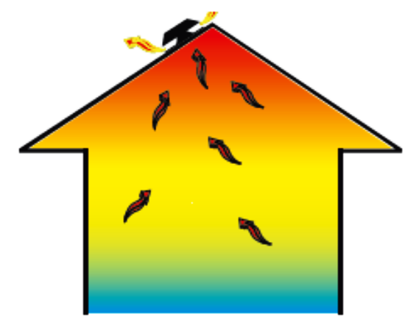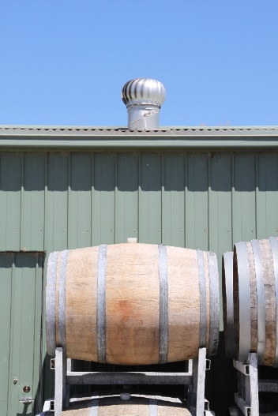

Temperature variations according to height in a building and example of hot air extraction under the roof in the McLaren Vale region of Australia.

3-2 _Isolation

The insulation of a building is one of the most important points in eco-design. An insulator is characterized by a coefficient of thermal conductivity expressed in W/M/°C. There are also some multilayer materials that act on the reflection of infrared radiation. Their thermal characteristics are proportional to the reflection coefficient of the metallized films and the number of internal reflective films. These materials, whose cost is generally higher than conventional insulation, have a thin thickness (1 to 3 cm), which is particularly interesting for under-roof insulation.

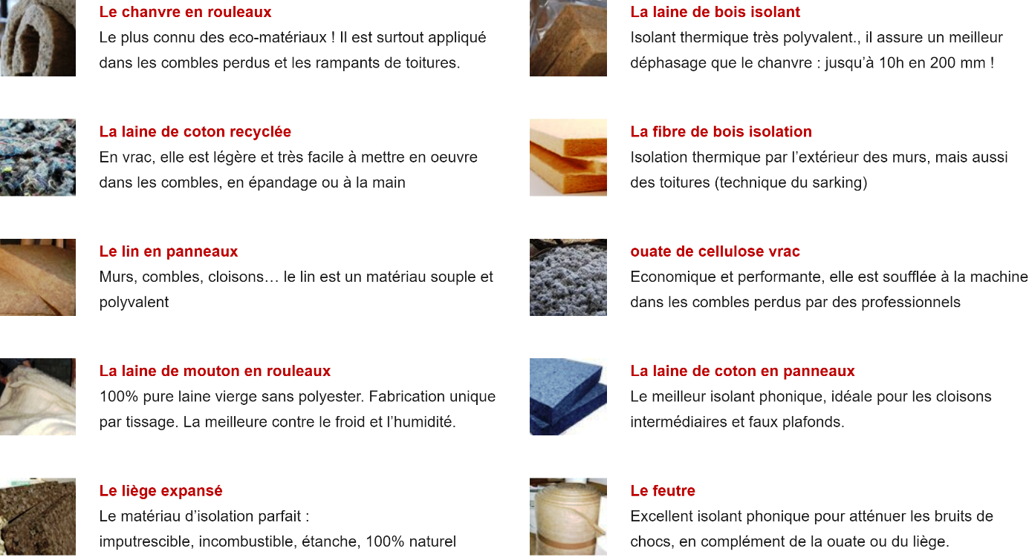

Some examples of ecological insulators, source www.eco-logis.com.

In addition to the insulating power, several aspects must be taken into consideration:

Humidity + Humidity
The insulation must not be a support for mould growth. For rooms sensitive to humidity, the protection of the insulation with a surface material (cladding, plasterboard) does not generally provide complete protection against the development of mould. It is often preferable to use insulations that are not very sensitive to moisture.

+ Shock resistance and pressure washer
The choice of insulation coating depends on the use of the room. For sensitive areas, there are products whose protective material (latex mortar, P. V.C., stainless steel, treated metal) is integrated into the insulation. The implementation of such products (cost of insulation and installation accessories, labour) must be studied compared to conventional solutions (double partition, mesh plaster).

Available thickness + Available thickness
For some installations, wall insulation can lead to a significant loss of space. In this case, it is advisable to choose multilayer materials or excellent conventional insulation (polyurethane or extruded polystyrene). However, the cost per unit area of these insulators is generally higher than that of conventional materials.
In recent years, building owners have sought to improve insulation ecobalances with materials that are less toxic, recycled or recyclable, that consume less energy and yet have a performance that is superior to or equal to that of conventional insulation. Ecological insulation is a building material that meets both the usual technical and environmental criteria throughout its life cycle. Ecological insulators are generally of mineral, vegetable or animal origin.

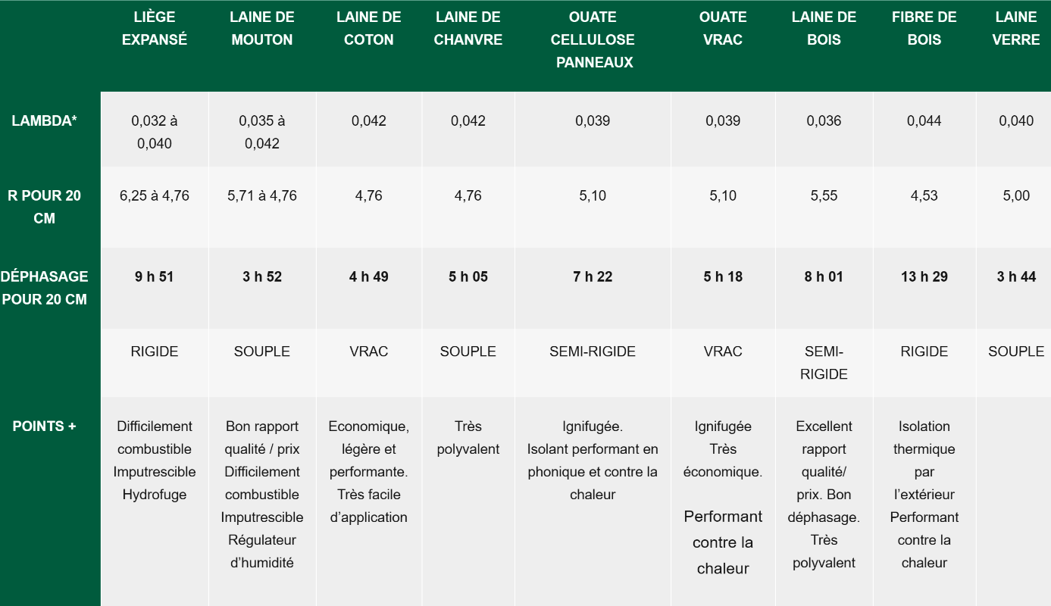

Characteristics of the main ecological insulators source www.eco-logis.com

3-3_ Plant structures

The concept of a green wall or roof is based on the creation of horizontal or vertical ecosystems associated with a building. It consists in covering a flat or slightly sloping roof (up to 35° of inclination) or a wall with a plant substrate.
In addition to the aesthetic aspect, this concept has a significant technical and ecological advantage. Plant walls and roofs have an important thermal and acoustic role by reducing thermal or solar reflections and radiation and also ambient humidity by evapotranspiration. At the same time, ambient air quality is improved through dust fixation and CO2 absorption by plants. By retaining rainwater, green roofs reduce flood peaks. For surface or semi-buried cellars, plant walls and roofs are an integral part of the landscape and contribute to developing the biodiversity of wine-growing buildings in their environment.
The construction of a green wall or roof must be adapted to the building and not degrade it. This requires permanent drainage under all loads, especially on shallow slopes, water and air supplies and insect protection.

The type of plants planted must be chosen according to the climate of the region, the sunshine, and the integration into the landscape.
There are different techniques for designing a green wall. The most common is to build a vertical steel structure parallel to the building façade as a support. The space between the wall and the structure allows air to pass through and keeps the wall away from the damp wall. PVC plates are attached to it in order to staple polyamide felt plates? used to support the plants; the use of a substrate is possible. The plants are inserted into the felt.
The green roof is based on a horizontal structure made of concrete, steel or wood that must support the weight of the installation. During rainfall or snowmelt, this weight can double or even triple, so it is recommended to provide a slope of 1 to 2% to reduce this overload.

In both cases, the choice of plants depends on the climate of the region, the sunshine, the slope of the roof, the type of wall (indoor or outdoor) and other functional criteria. For outdoor use, it is preferable to choose perennials and native plants that are highly resistant to extreme temperatures (grasses, green or flowering plants).
Depending on the type of substrate and the degree of watering desired, the plantation can be extensive, semi-extensive or intensive.

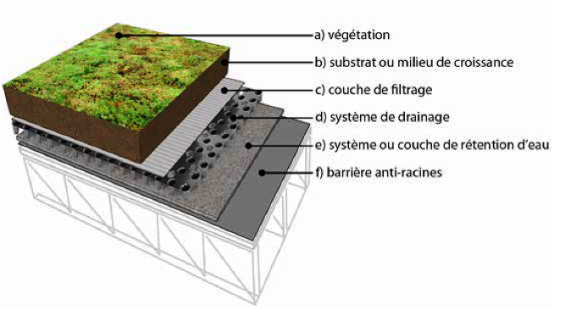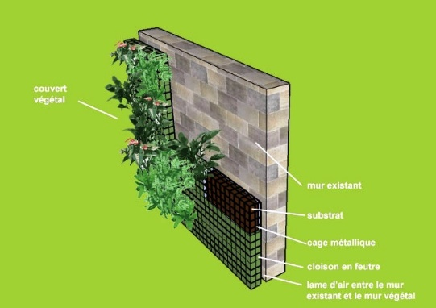

Schematic diagram of a green roof (Illustration by Danny Aubin Source: www.ville.montreal.qc.ca) and a green wall (www. murmurevegetal. com)

4 _ NEW ENERGY SOURCES.

Alternative energies can be implemented collectively. The reflection can also be carried out at the cellar level. Depending on the region, wind energy can be used for low electricity consumption (light) or pumping operations (water, effluents). Solar energy is gradually developing in the wine sector, particularly in the southern regions. Several approaches can be considered:

+ Bioclimatic architecture:
This approach consists in optimizing the natural cooling by the cellar environment. A few examples illustrate the diversity of possible solutions (vegetation walls to cut off the wind, picture windows to the south, ventilation on the north side, etc.)…… )

+ Solar heating:
A series of water collectors are placed on the roof to produce hot water or heat buildings.

+ Photovoltaic conversion:
It is a direct transformation of light into electrical energy. The flat photovoltaic cell has two areas of different electrical characteristics in its thickness. When light illuminates the cell, photons generate electrical charges stored in batteries.

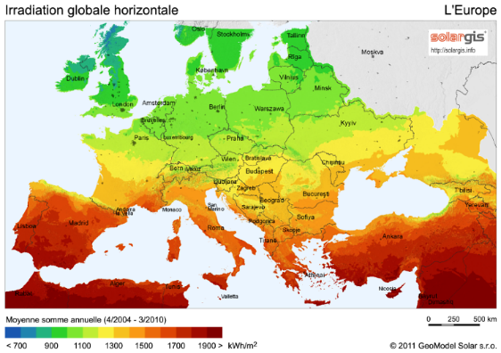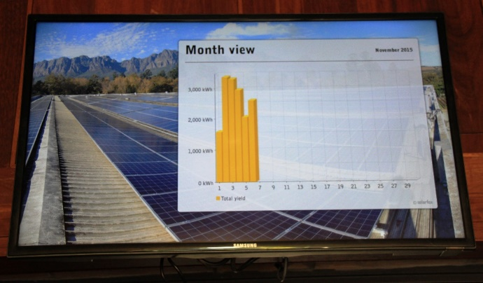

Solar potential map in Europe (Geomodel solar 2011) and communication of photovoltaic energy production to visitors to the cellar (Lourensford winery in the Stellenbosch region of South Africa).

5 _ EXAMPLES OF ECODESIGNED CELLARS

5-1 _ Domaine Léon Boesch in Alsace

Designed by architect Matthieu Winter, the vineyard is built from a
wooden frame, traditional construction method in Alsace. The construction involves
including dry stone foundations, a green roof, wall insulation, etc.
in bales of straw, etc. The raw materials come from the surroundings of the wine village. The
foundations are made of limestone rocks one metre thick to ensure
the hygrometry and "breathing" of the cellar. The cellar to the north benefits from the coolness, while the dwelling house to the south benefits from the sunshine.

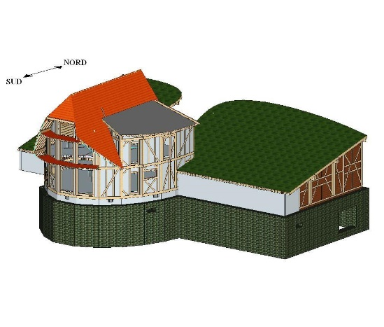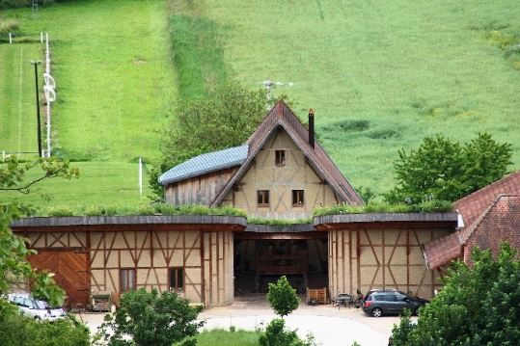

Plan and general view of the Léon Boesch cellar.

5-2_ Gramona Cellar in the Penedès region of Catalonia

The cellar has a very large green roof area covered with vines, which ensures natural air conditioning. This upper vegetal area includes old grape varieties that enhance the Penedès grape variety and an area composed of local plants linked to biodiversity and the geological characteristics of the terroirs. Windows are open on the green roof with protection against excessive sunlight. It is also equipped with new energy sources: geothermal energy, solar panels.

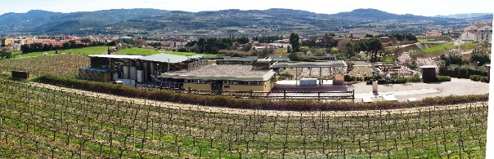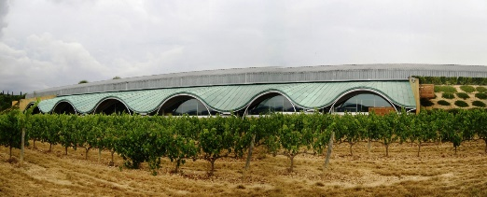

Overview of the cellar and the "bottle stack" natural lighting of the Gramona cellar.

5-3 _ Cave Le Mortelle of the Antinori group in Tuscany.

This cellar has been designed to limit the impact on the environment and to integrate optimally into the surrounding hills. This design is based on a surface skylight and a "greening" of unburied areas. The cellar has a semi-underground hemispherical shape, largely hidden in a hill that is naturally located in the area. Spread over three floors, gravity facilitates transfers during the various vinification operations. From the top, the grapes are received on the second floor, then transferred by gravity to the lower floor to undergo the different types of vinification. The barrels are stored in the basement to ensure the ageing of the wine in conditions of natural freshness and humidity.

. 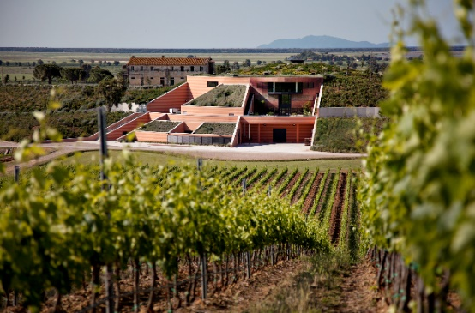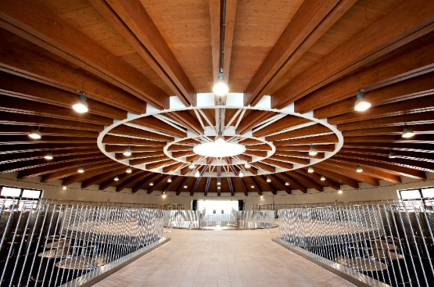

External and internal view of the cellar Le Mortelle. Photo www.antinori.it

5-4 _ Château Cheval Blanc in the Bordeaux region of Saint-Émilion

The modern and ecological design of the cellar fits perfectly into a local UNESCO World Heritage Site.
Designed by Christian de Portzamparc and inaugurated in June 2011, the Cheval Blanc cellar emerges with two waves of white concrete topped by a green roof. It has the High Environmental Quality (H.Q.E.) label for the choice of construction materials, energy savings, water management and waste sorting, but also for the acoustic comfort, safety and well-being of the staff.

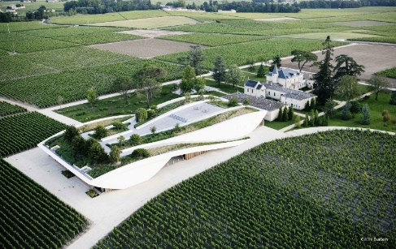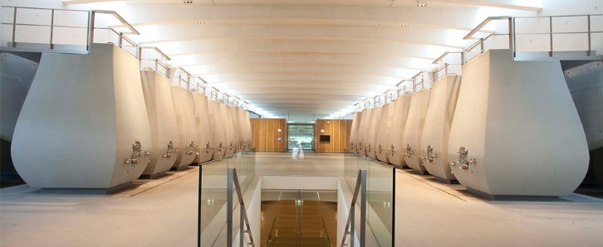

Aerial view and photo of the Château Cheval Blanc winery. Photo Celine Burban.

6 _ CONCLUSION

Until now, energy aspects have not been a major concern for the wine industry. It must be said that we are now entering a period of fossil fuel depletion, with increasing pressure to reduce the greenhouse effect. For all cellars, it is first necessary to quantitatively determine consumption by type of activity and to estimate the overall needs of the sector (direct and indirect) and if possible to determine the environmental impact of this thermal management. This environmental aspect is also included in the selection of applications for FranceAgriMer investment aid.

The optimal design of buildings, with good insulation, possibly complemented by ecological measures (green roofs or walls, etc.) and alternative energies (solar, geothermal, Canadian wells, biomass, etc.) is part of this modern and sustainable cellar design dynamic.
At the same time, the wine sector constitutes an important source of by-products and organic waste. Optimized energy recovery can be considered.
These aspects, as well as the integration of the landscape, contribute to enhancing the cellar's environmental image. In addition, regulations and standards are evolving, which justifies anticipating environmental requirements in order to avoid costly changes in compliance with standards in the coming years.

BIBLIOGRAPHY

+ B. PEUPORTIER, Éco-conception des bâtiments et des quartiers, Editions Mines Paritech (2008)
+ J. Rochard, Traité de viticulture et d’œnologie durable, éditions Avenir Oenologie (2005)
+ L.Van Gysel, I. Pierot, J. Ducruet, Éco-conception : Solution pour nos caves de demain, Objectifs 79, Aout (2013)
+ J. ROCHARD, R.F.O., Du paysage à l’éco-conception des caves : l’oenologue ambassadeur de l’éco-Oenotourisme, 252, mai/juin (2012)
+ D Marengo, J Rochard, Revue des Œnologues, Besoins thermiques d'une cave, 145, novembre (2012)
+ N. Dunnett et coll., Toits et murs végétaux, Edition de Rouergue (2008)
+ IFV, Comptabilisation des émissions de gaz à effet de serre : application de la méthode Bilan Carbone® à la filière viti-vinicole (2011), téléchargeable : www.vignevin.com/publications/collection-itineraires.html
+ IFV, Plaquette : Quelle gestion des sous-produits vinicoles, (2003), téléchargeable : www.vignevin.com/publications/collection-itineraires.html
+ V. Lempereur, S. Penavayre, Grape marc, wine lees and deposit of the must: how to manage oenological by-products?, congress OIV Mendoza (2014)

